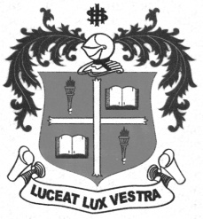
LOYOLA COLLEGE (AUTONOMOUS), CHENNAI – 600 034
B.A. DEGREE EXAMINATION – HISTORY
FIRST SEMESTER – NOVEMBER 2012

HT 1504/1502/1500 - CULTURAL HERITAGE OF ANCIENT INDIA

Date : 08/11/2012 Dept. No. Max. : 100 Marks
Time : 1:00 - 4:00

PART A

Answer any TEN of the following in TEN lines each: (10x2=20)

- Numismatics
- Allahabad pillar Inscription
- Hiuen Tsang
- Arthasastra
- Rig veda
- Polygamy
- Inscriptions of Asoka
- Espionage system
- Gandhara Art
- Mahavira
- Guilds
- Ajanta paintings
PART B

Answer any FOUR of the following questions in about ONE page each: (4x10=40)

- Discuss the sources for the study of ancient India.
- Give an account of the political organizations of the Vedic Age.
- Bring out the origin and development of caste system in India.
- Examine the status of women during the Pre-Mauryan period.
- Discuss the administrative system of the Guptas.
- Analyse the impact of Buddhism on society and culture.
PART C

Answer any TWO of the following questions in about FOUR Pages each: (2x20=40)

- Write on the geographical features of India and its effects on history.
- Review the salient features of Indus Valley Civilization.
- Give an account of the growth of trade and commerce in ancient India.
- Evaluate the cultural contribution of the Guptas.
$$$$$$$

